TERMS AND CONDITIONS FOR THE USE OF IMAGES
FOR THE ARTWORKS AS SUPPLIED BY THE
NATIONAL GALLERY OF VICTORIA FOR THE
Melbourne Design Week
These images are only to be used in a non-commercial manner for editorial coverage solely to review or promote Melbourne Design Week

- Any use of these images outside of direct and clear review or promotion of the exhibition is in breach of copyright and may result in legal action.

- Every appearance of these images must be accompanied by the correct caption, provided by the National Gallery of Victoria below. Captions must appear in the format shown below.

- Image integrity must be maintained, in that each image must be shown in full with no cropping, overprinting or changes to proportions or ratio.

- These images can only be reproduced in association with the current exhibition, and must not be reproduced once the exhibitions have finished

- If you wish to reproduce these works for any other purpose, the National Gallery of Victoria must be alerted, as copyright restrictions apply for all of the works.

- The National Gallery of Victoria is not responsible for any breaches of the conditions listed above, and any liabilities or expenses arising out of any claim by the copyright holder for the violation of these conditions is the responsibility of the party violating these rights.

- The numbers highlighted in yellow are the image reference numbers to identify the works and should NOT be included with the caption.

- Please ensure that a copy of the article in which this image is reproduced is sent to the Media and Public Affairs Department, National Gallery of Victoria, PO Box 7259, Melbourne Vic 8004 or email a copy to Marion Joseph: marion.joseph@ngv.vic.gov.au

Image | Caption
Portrait imagery  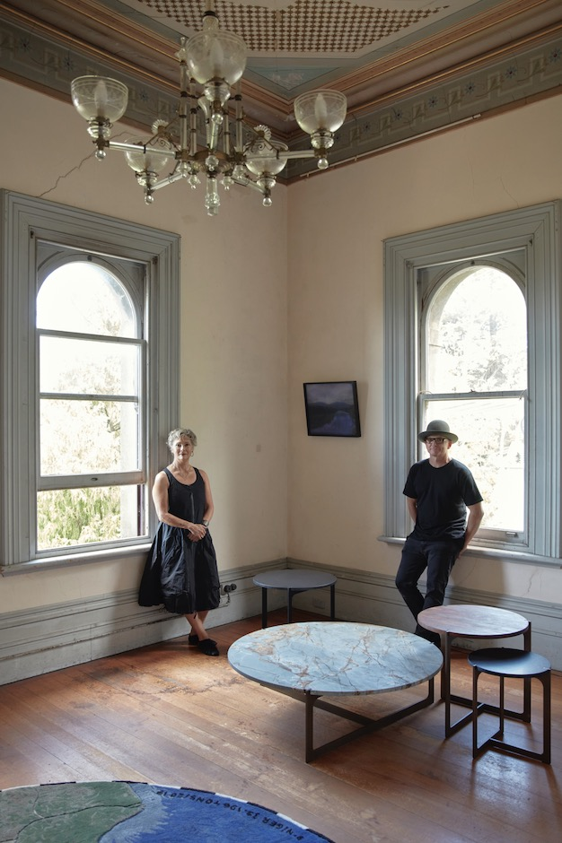  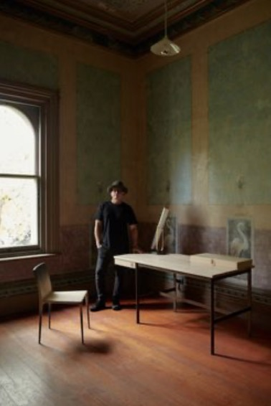 | Adelaide-based furniture designer Jon Goulder, and Sydney design retailer Fiona Lyda, at Futures Collective presented by Spence & Lyda during Melbourne Design Week 2022  Photo: Sean Fennessy
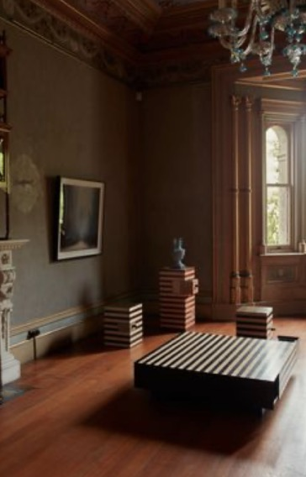  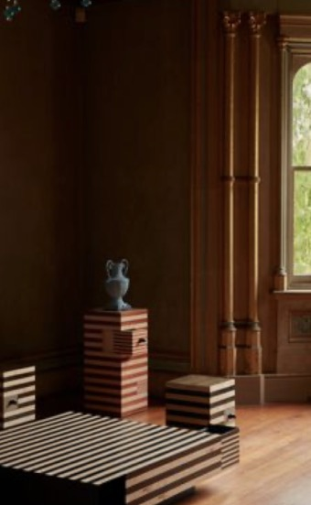  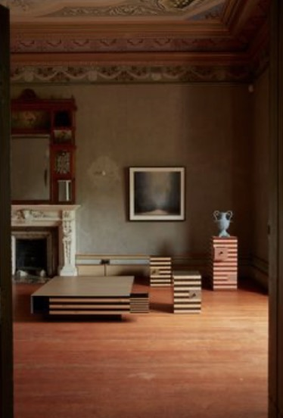 | Broached Commissions on display at Futures Collective presented by Spence & Lyda during Melbourne Design Week 2022  Photo: Sean Fennessy
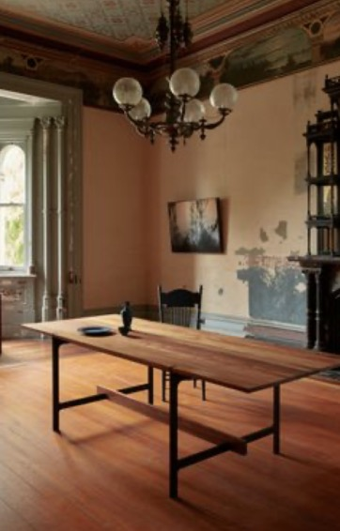

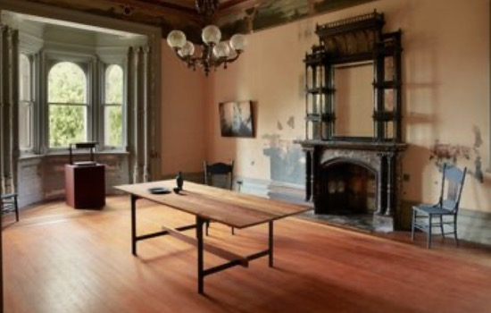
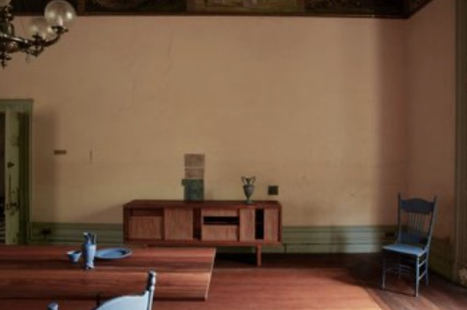

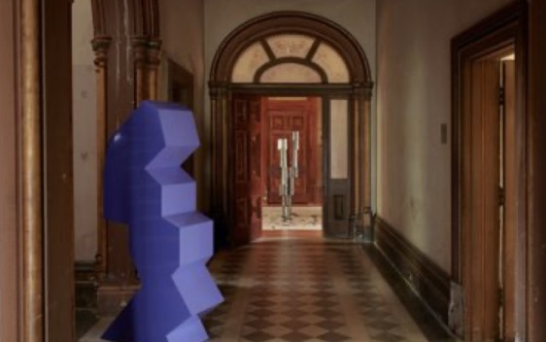  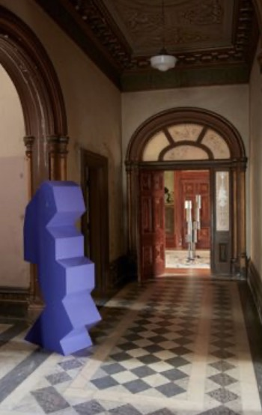  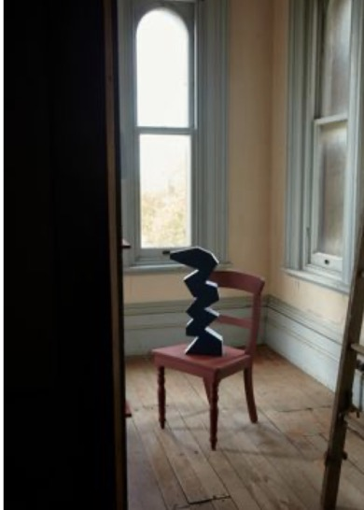 | Greg Penn curated by Otomys on display at Futures Collective presented by Spence & Lyda during Melbourne Design Week 2022  Photo: Sean Fennessy
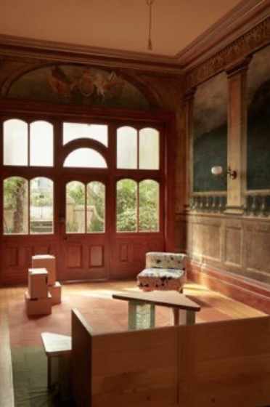  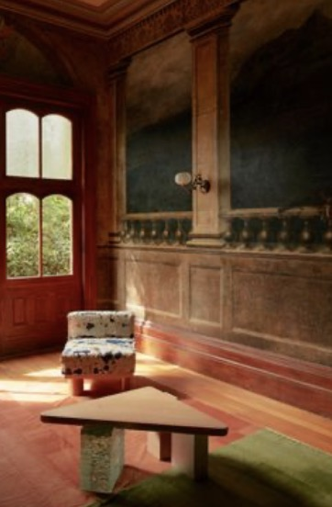  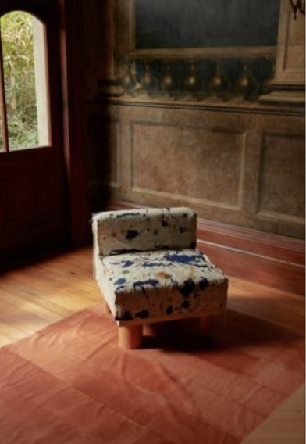  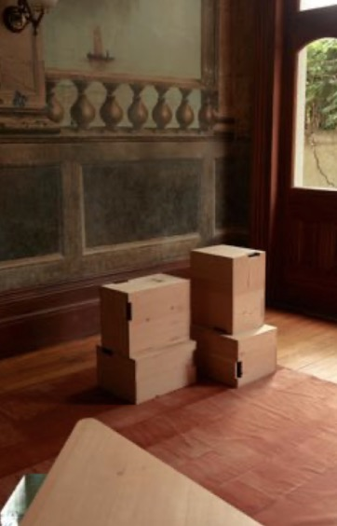  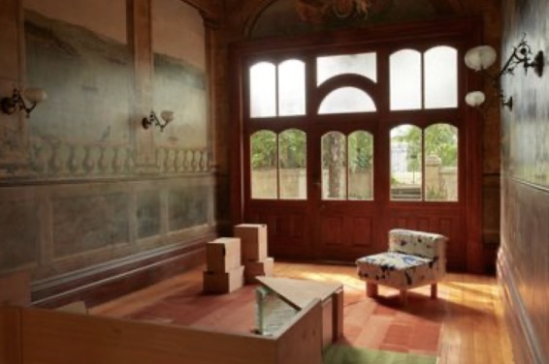 | Fiona Lynch on display at Futures Collective presented by Spence & Lyda during Melbourne Design Week 2022  Photo: Sean Fennessy
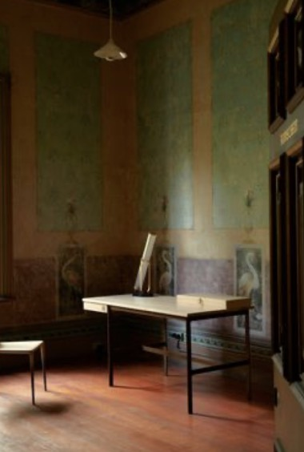 | Futures Collective presented by Spence & Lyda during Melbourne Design Week 2022  Photo: Sean Fennessy
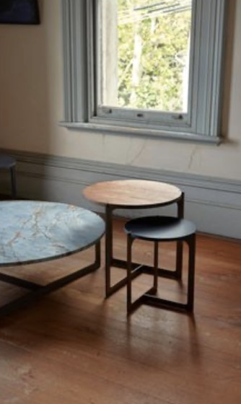

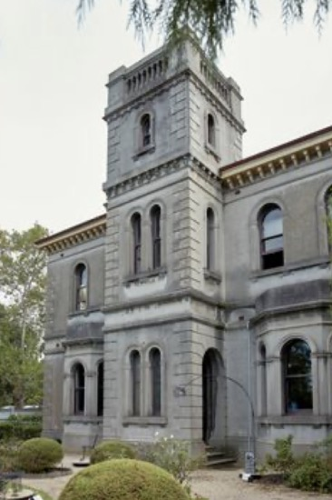 | Futures Collective presented by Spence & Lyda during Melbourne Design Week 2022  Photo: Sean Fennessy

