Article Title: Restrained Warmth – House E by CJH Studio
Author: Bronwyn Marshall
Link to Dropbox folder of low-res imagery: https://www.dropbox.com/scl/fo/ogvj0bbfm2zuoct4ge8u2/h?dl=0&rlkey=40yir3gasw70vrbygqhibodsx
Feature Type: Project Feature
Location: Elsternwick, VIC, Australia

Blog Description: Imagined as a timeless and enduring residence, sees CJH Studio capture a sense of robustness amongst a highly refined and carefully executed series of spaces that combine an appreciation for minimalism and restraint.

Meta Description: House E sees CJH Studio create moments where classical finishes emerge in a contemporary way, to form a lasting and sculptural feeling within, while ultimately conjuring the familiar and enveloping warmth of a home.

Photographer: Timothy Kaye | https://www.timothykaye.com/
Interior Design: CJH Studio | https://cjhstudio.com.au/
Build: Omnicon Constructions | www.omnicon.com.au/
Joiner: Grange Joinery | www.grange-joinery.com.au/
Styling: CJH Studio | https://cjhstudio.com.au/

Digital Instagram Caption: Project Feature • Imagined as a timeless and enduring residence, House E captures a robustness amongst a highly refined and carefully executed series of spaces that combine an appreciation for minimalism and restraint. CJH Studio create moments where classical finishes emerge in a contemporary way, to form a lasting and sculptural feeling within, while ultimately conjuring the familiar and enveloping warmth of a home.

Head to the link in bio to read Restrained Warmth – House E by CJH Studio on The Local Project.

Photography by @timothykaye.
Interior Design by @cjh____________studio.
Built by @omnicon_constructions.
Joinery by @grangejoinery.
Styled by @cjh____________studio.
-
Location: Elsternwick, VIC, Australia.

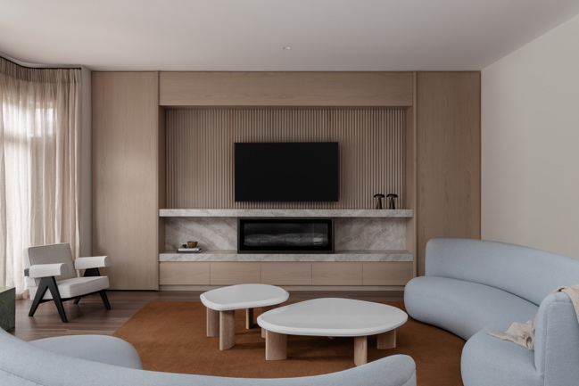

Imagined as a timeless and enduring residence, House E captures a robustness amongst a highly refined and carefully executed series of spaces that combine an appreciation for minimalism and restraint. CJH Studio create moments where classical finishes emerge in a contemporary way, to form a lasting and sculptural feeling within, while ultimately conjuring the familiar and enveloping warmth of a home.

Located in the inner east of Melbourne, in Elsternwick, House E balances both the practicalities of daily life with an elevated luxury throughout. While the outer limits of the spaces were already set, the new interior reworks the existing home to both reflect and capture the owners presently, while also carving an ideal backdrop for their coming chapters. As both a reflection of their tastes and a statement in stage of life, the materiality combines a natural focus with one requiring minimal maintenance. CJH Studio propose a minimal palette that is expressed through linear elements and a lasting resolve, to create a heightened approach to the everyday experience of the home.

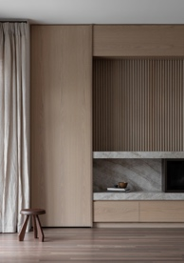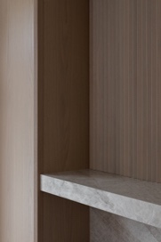

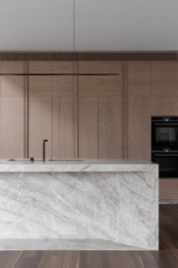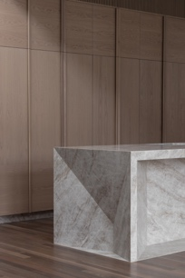

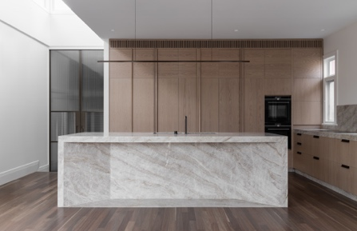

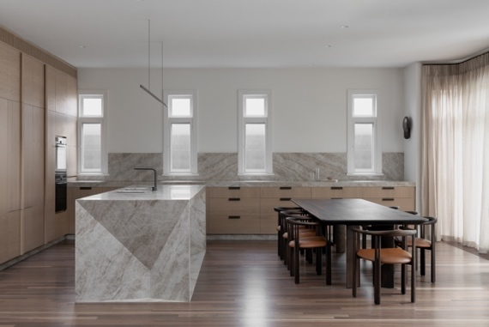

Having recently downsized from a much larger property, the owners wanted to bring a similar charm and detailed nature with them into the new space was key, while also being able to add their own collected treasures in the process. As a neutral base for the happenings and bustle that life brings, the resulting spaces are intended to remain relevant for many years to come, and the overlaying of warmth inevitably ties the spaces together. With the process of moving being a cathartic one, the refining of what is important forms the focus for the new home, as a drawing in on priorities and a reassessment of what the new spaces will be, and how they will serve the owners.

To combat the slightness of the spaces, a focus on creating a more sculptural feel forms the basis for the new. Combining American oak throughout, with light coloured marble and brass detailing, every element has been considered, with junctions expressed with precision. Having come from a traditional home and being surrounded by other homes in the area that reflect a similar sensibility, retaining elements such as chandeliers, fireplace mantels and classic details was key. The difference being that these are reinterpreted through a cleaner and linear approach, crafted with the hands of modern artisans.

As a neutral base for the happenings and bustle that life brings, the resulting spaces are intended to remain relevant for many years to come, and the overlaying of warmth inevitably ties the spaces together.

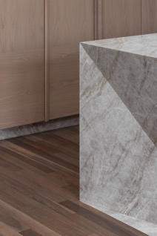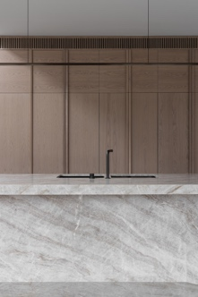

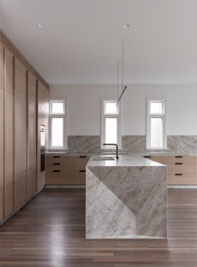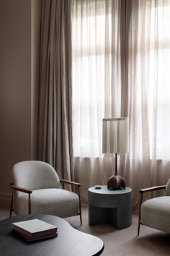

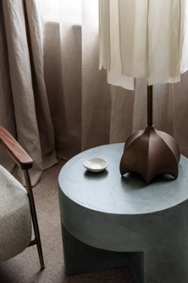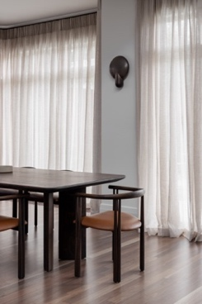

Coming together as a soft and cocooning home, House E celebrates a beauty in simplicity. By ensuring a pared back, yet highly vigoured approach is overlaid throughout, CJH Studio propose a lasting and classically modern base for the owners.

With the process of moving being a cathartic one, the refining of what is important forms the focus for the new home.

